ITA0305- Mobile Computing
LAB EXPERIMENT
Name: G.Ganesh
Reg NO:192373008

19. Analyze signal strength between nodes in a simulated environment.

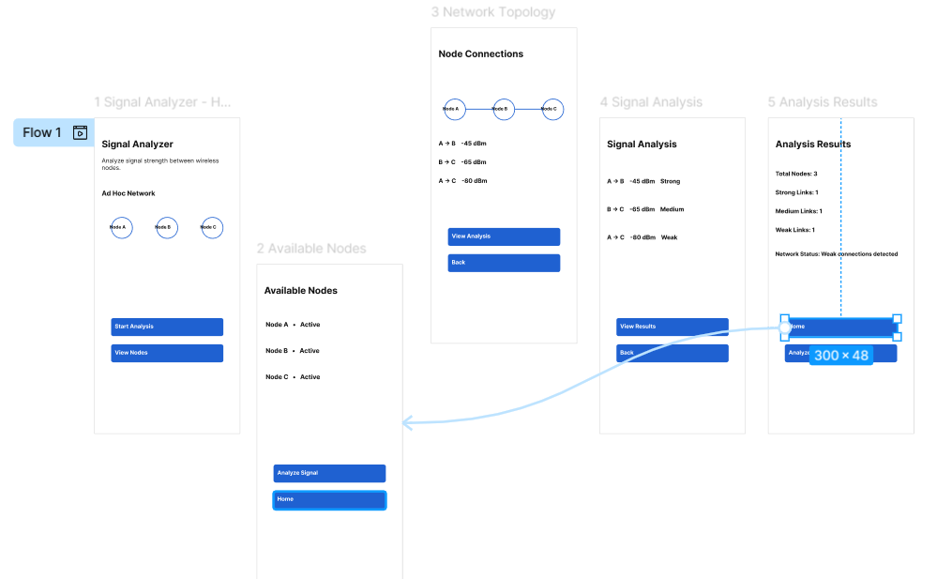
https://www.figma.com/design/ptL1gbbVldIh4M4sme7L2E/program19?node-id=10-65&t=u9JhsTfBZbGnmDAY-0

